Pre-Owned 2015 Nakamura WY 100

Fanuc 31iA Control, Parts Catcher G

Sold New 2015

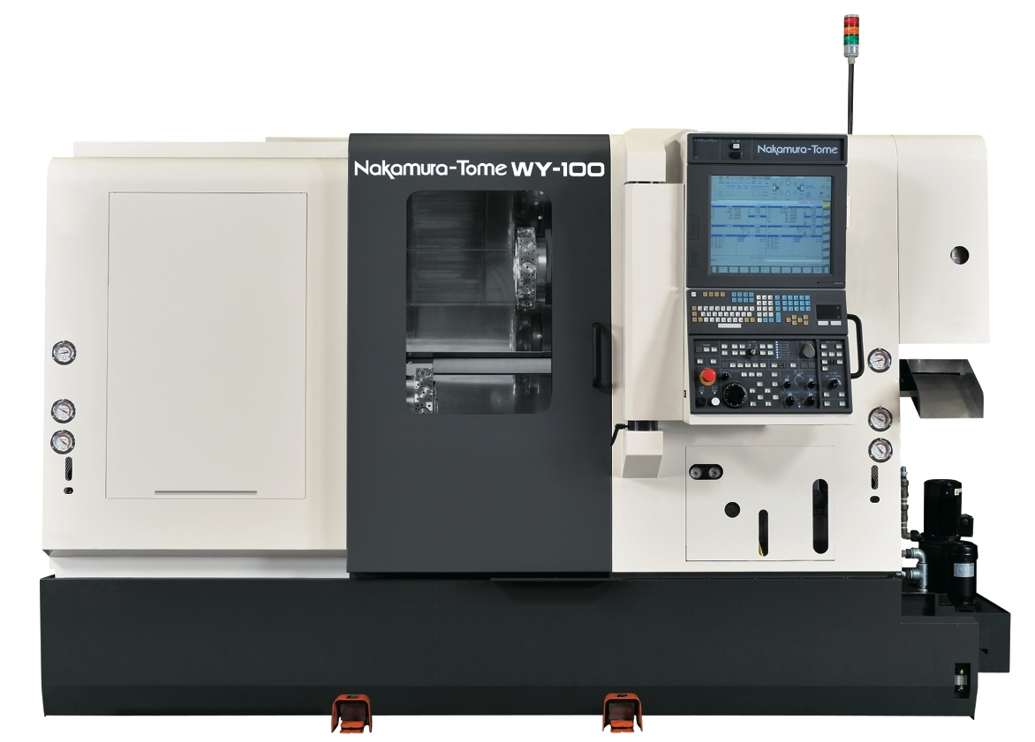

New Nakamura-Tome WY-100 , NT-IPS 19” Color LCD +

Fanuc 31iA Control, PC-G

2.0 Inch (51mm) Bar Capacity Left Spindle, 42 MM Right Spindle

CNC Turning Center

MTA Company Inc., 3440 Ellicott Center Drive, Suite 105, Ellicott City, MD 21043
410 750 1130 Office, 410 750 6332 Fax

Nakamura-Tome WY-100 , PC-G, CNC Turning Center with NT-IPS 19 In LCD + Fanuc 31i-A CNC Control, as per standard specifications attached including:

- 5,000 RPM Spindle Speed – 10/15 HP Fanuc Spindle Motor – Left Spindle
- 6,000 RPM Spindle Speed – 10/15 HP Fanuc Spindle Motor – Right Spindle
- 2.0” (51mm) Bar Capacity Left Spindle
- 1.65” (42mm) Bar Capacity Right Spindle
- Chuck Open/Close Foot Switch
- Fixed Airblow Left / Right Spindles
- Full "C" Axis Milling Unit Left and Right Spindles
- Kitagawa 6" 3 Jaw Chuck for Right Spindle B-206A0545
- Luck Bei II
- NT Nurse II System
- NT Work Navigator
- Parts Catcher "G" - 2.0” x 5.9" x 3.3 Lbs. Capacity
- Safety Interlock for Chucking Failure
- Spindle Lock for Main and Sub
- Spindle Speed Override Switch Left / Right Spindles
- Splash Guards with Safety Door Interlock
- Helical Interpolation
- Standard Tool Holder Package
- Work Light
- Y Axis Function Upper and Lower Turret
- Caron Engineering TMAC and Auto Comp

Machine to Include:
LNS Quick Load Servo 80 S2 Barfeed
Chip Conveyor
Triple Alarm Light
Coolant/Air Flush Right Side
Auto Power Off
MMT CTS 2 Pump System
CAMPlete Included
Alberti 2 Cross Drill & 2 Face Drills
Workholding Left Side 2” ATS A5S20 True Lenghth
Workholding Right Side 41MM ATS True Lenghth A5-16CTLS
MistBuster Floor Mount 850

Sale Price $294,900.00
Fob Shipping Point, Payment Due with Order
Sold As Is Where Is, No Warranty Implied or Expressed
Available for Inspection
Breakdown and Clean Up Included
Machine Loading Not Included
MTA Terms and Conditions Apply

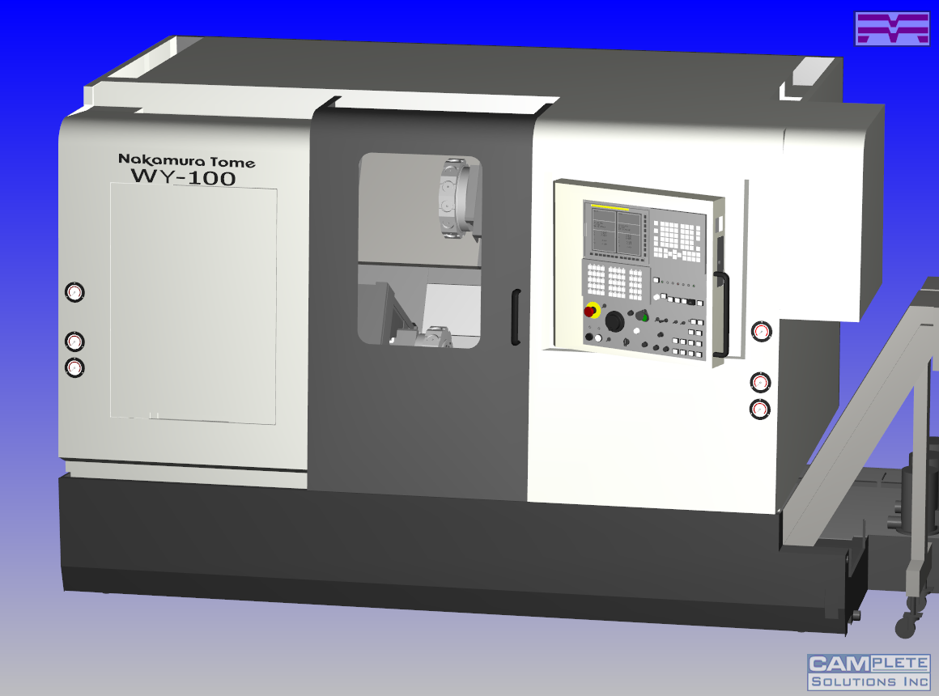

Simulation
  - Full Simulation of Nakamura Turning Centers and Programs
  - Detailed Tooling and Workholding Libraries

G-Code Editing
  - Editor Allows Modification of Posted or Unposted Data
  - Changes Automatically Updated to Both Toolpath and G-Code

Optimization
  - Wait Code Editing
  - Reorder and Move Operations
  - Fine Tune and Optimize to Simplify Multitasking

Analysis
  - Monitor All Aspects of Machine Motion: True Cutting Speeds,
Axis Velocity and Acceleration, and Motion Deviations

Verification
  - Verification of Machine, Tooling, and Workholding Using Detailed
Nakamura Machine Models
  - G-Code is Verified

NT-IPS Nakamura-Tome Intelligent Production System

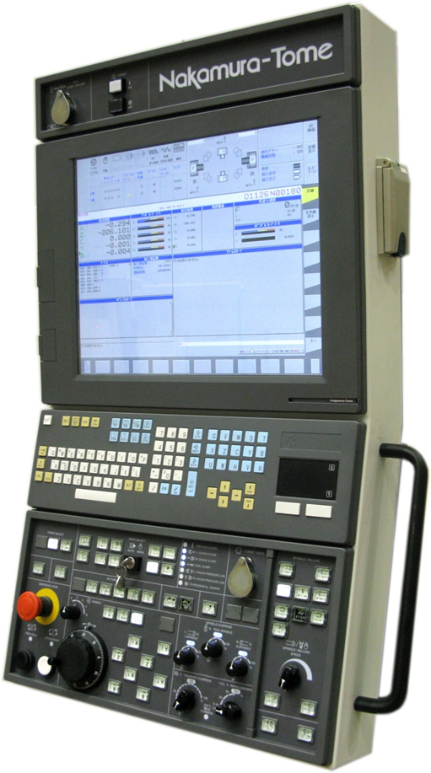
NT-IPS Windows Version System Specifications
Hard Disk C and D
C = 24Gb
D = 4Gb
Memory Size = 2Gb of Ram
Processor = Intel®Pentium®
Dual CPU
19” High Resolution Screen

Standard on all Nakamura Multitasking Models
NT-IPS Nakamura-Tome Intelligent Production System

Additional Features ( Custom Pages )
- NT Setting Page:
- Displays the Machine Conditions
- Status and Program Page:
- Program, Mode, Path and Machine
- Tool Setting Page:
- Mode, Work Coordinates 1, 2 and 3
- Tool information, Geometry and Position
- Manual Guide I + Load Monitor:
- 3D Machining Simulation
- G-Code Program Produced
- Load Monitoring Each Axis + Each Spindle
- Maintenance + Alarm Trouble Shooting
- Step by Step Guidance with pictures and procedures to resolve the issue
*All Machine manuals are embeded in the control
- Qty. 1: CF card slot ( Memory card Input/output )
- Qty. 2 : USB ports + 1- AC 100V plug

The WY-100 is the turning machine that is successfully differentiating itself from others when it comes to Multi-tasking. This premiere machine has two high rigidity turrets and Y-Axis for both turrets. A new and innovative machine is born. In addition to the advantages of simultaneous machining on the left or right hand spindles, the introduction of Y-Axis on both turrets contributes to increased productivity.

By using the Y-Axis for simultaneous machining with the upper and lower turrets, machining process layout optimization becomes a reality. Whether machining with multiple tools simultaneously on one side, or on both the left and right hand sides, cycle time is dramatically reduced.

The WY-100 is a High Productivity Multi-tasking Turning Center that is at the cutting edge of speed.

Therefore, In accordance with your request, we are pleased to submit the following specifications for the Methods WY-100 CNC Turning Center with the Fanuc 31i-A CNC Control. Attached are the Terms and Conditions sheets covering warranty and other aspects of eventual machine tool sale. Applications Engineers are always available at our Technical Center in Sudbury to answer any questions you may have.

Standard Machine Specifications
Capacity
- Distance between centers
- (MAX/MIN) 32.28/7.87 in. (820/200 mm)
- Max. turning dia. 6.89 in. (175 mm)
- Std. turning dia. 6.69 in. (170 mm)
- Max. turning length 23.15 in. (588 mm)
- Bar capacity left spindle 2.0 in. (51 mm)
- Chuck size 6 in.
- X-axis thrust force (X1/X2/) 674 lbf (3000N)
- Z-axis thrust force (Z1/Z2) 1124 lbf (5000N)
- Y-axis thrust force (Y1/Y2) 674 lbf (3000N)
Stroke
- X-axis (X1/X2) 5.31 in. (135 mm)
- Z-axis (Z1/Z2/Z3) 9.6/9.6/22.75 in. (245 / 245 / 578 mm)
- Y-axis (+31/-31) (Y1/Y2) 2.44 in. (62 mm)
- B-axis 24.41 in. (620 mm)
L-spindle
- Spindle speed 5000 (min-1)
- Spindle speed range Stepless
- Spindle nose A2-5
- Hole through spindle 2.480 in. (63 mm)
- I.D. of front bearing 3.540 in. (90 mm)
- Hole through draw tube 2.0 in. (51 mm)
- Spindle bearing support 2 positions
- Spindle center height 47.24 in. (1200 mm)
R-spindle
- Spindle speed 6000 (min-1)
- Spindle speed range Stepless (min-1)
- Spindle nose A2-5
- Hole through spindle 2.20 in. (56 mm)
- I.D. of front bearing 3.15 in. (80 mm)
- Hole through draw tube 1.69 in. (43 mm)
- Spindle bearing support 2 positions
C-axis
- Index mechanism V-belt
- Max. programmable index angle +/- 99999.999degree
- Least input increment 0.001degree
- Least command increment 0.001degree
- Rapid index speed 600 min-1
- Cutting feed rate 1 - 4,800degree/min
- Index accuracy 40 sec.
- Repeatability less than +/- 30 sec.
- Simultaneously controlled axis 3 (X+Z+C) axis
- C-axis clamp Disk clamp
- Braking torque 45N .m
- C-axis connecting time 1.5 sec.
Upper turret (R)
- Turret head type Dodecagonal drum
- Number of tool stations (Each turret) 12 st.
- Number of index position(Each turret) 24 pos.
- Tool size - square 0.79 in. (20 mm)
- Tool size - round 0.98 in. (25 mm)
- Index time - half round 0.7 sec.
- Index time - 1 station 0.2 sec.
- Turret head outside diameter 11.81 in. (300 mm)
- Thickness 2.44 in. (62 mm)
- Clamping force 20.5 kN
- Index mechanism Servo motor
- Clamping mechanism 145mm diameter) Curvic
- Tooling clearance 19.09 in. (485 mm)
Lower turret (L)
- Turret head type Dodecagonal drum
- Number of tool stations (Each turret) 12st.
- Number of index position (Each turret) 24 pos.
- Tool size - square 0.79 in. (20 mm)
- Tool size - round 0.98 in. (25 mm)
- Index time - half round 0.7 sec.
- Index time - 1 station 0.2 sec.
- Turret head outside diameter 11.81 in. (300 mm)
- Thickness 2.44 in. (62 mm)
Lower turret (L)
- Clamping force 20.5 kN
- Index mechanism Servo motor
- Clamping mechanism (145 mm diameter) Curvic
- Tooling clearance 19.09 in. (485 mm)
Rotating tool (Upper R and Lower L)
- Number of rotating tool stations (Each turret) 12
- Rotating tool speed 6000 min-1
- Rotating tool speed range Stepless
- Max. rotating tool shank - straight drill 0.5 in. (dia. 1 – 13 mm)
- Max. rotating tool shank - cross drill 0.5 in. (dia. 1 – 13 mm)
- Saddle Construction 60 degree
- X1 / X2 / 32 / 32 mm
- Z1 / Z2 / 32 / 32 mm
- B2 32 mm
- Y1 / Y2 / 32 / 32 mm
- Ball screw pitch: 8 / 8 mm
X1 / X2 /
Z1 / Z2 / 12 / 12 mm
B2 12 mm
Y1 / Y2 6 / 6 mm
- Distance between slides:
X1 / X2 220 / 220 mm
Z1 / Z2 300 / 330 mm
B2 225 mm
Y1 / Y2 170 / 170 mm
Cutting feedrate
- Rapid traverse
X1 / X2 630 ipm (16000 mm/min)
Z1 / Z2 1575 ipm (40000 mm/min)
B2 1575 ipm (40000 mm/min)
Y1 / Y2 246 ipm (6000 mm/min)
- Cutting feed rate
X1 / X2 189 ipm (1 - 4,800 mm/min)
Z1 / Z2 189 ipm (1 - 4,800 mm/min)
B2 189 ipm (1 - 4,800 mm/min)
Y1 / Y2 189 ipm (1 - 4,800 mm/min)

Cutting feedrate (Cont.)
- Jog feed
X1 / X2 50 ipm (0 - 1,260 mm/min)
Z1 / Z2 50 ipm (0 - 1,260 mm/min)
B2 50 ipm (0 - 1,260 mm/min)
Y1 / Y2 50 ipm (0 - 1,260 mm/min)
- Drive motor
- Left spindle(S3 : 25% / S1 : CONT) 15/10HP (11/7.5 (75N.m) kW)
- Right spindle (S3 : 25% / S1 : CONT) 15/10HP (11/7.5 (75N.m) kW)
- Rotating tool spindle(S3 : 15% / S1 : CONT) 9.5/3HP (7.1/2.2 16N.m) kW)
- X1 / X2 -axis 2.40HP (1.8 kW)
- Z1 / Z2 -axis 3.40HP (2.5 kW)
- B2-axis 3.40HP (2.5 kW)
- Y1 / Y2 -axis 1.60HP (1.2 kW)
- Index 1.60HP (1.2 kW)
- Hydraulic pump 3 + 2 HP (2.2 + 1.5 kW)
- Lubrication pump 0.02HP (0.017 kW)
- Coolant pump .24 + 4HP (0.18 x 3 kW)
Power Requirement
- Power supply 56 KVA
- Air supply 150 - 200Nl / min(7 cfm max)
0.5 - 0.7MPa
Tank capacity
- Hydraulic tank (L+ R) ( 23 gal) 87 liter
- Lubrication tank ( 1.2 gal)4.6 liter
- Coolant tank ( 52 gal)220liter
Pump Delivery
- Hyd. pump delivery (L+R) 15 gal / min
- Hyd. pump delivery pressure 3.5MPa
- Lub. pump delivery 4.8cc/5 min
- Lub. distribution Intermittent quantitive

General
- Machine height 76.38 n. (1940 mm)
- Max height of moving area 82.13 in. (2086 mm)
- Floor space 110 x 77.5 in. (2,780 x 1,970 mm x mm)
- Floor space (Including Chip Conv) 161 x 77.5 in. (4,080 x 1,970 mm x mm)
- Maintenance space 149 x 105.3 in. (3,780 x 2,675 mm)
- Machine weight 7,400kg (16,317 lbs.)
Noise/Vibration
- Noise level - head stock less than 80dBA
- Vibration level - saddle less than 10V
Machine work light
- Type Florescent
- Lamps 13w
- Operating voltage 24
Chip Conveyor
- Disposal Direction Right
Part Catcher “G”
- Finger Gripper
- Part size:
- Diameter 2.0 in (51 mm)
- Length 5.9 in (.150 mm)
- Weight 3.3 lbs. (1.5 kg)
- Drive Hydraulic and Air
- Cycle Time 5
Part catcher type G
Capacity: DIA.51mm x L150mm / 1.5kg
Mounted on Right Spindle Side
5 Sets soft jaws are included
A part conveyor or a stock box outside the machine
shall be arranged locally if required

Standard Tool Holder Package

6 Ea. C21411 4 Ea. C22413
1 Ea. C21431AA 4 Ea. M2123
1 Ea. C21441AA 4 Ea. M2122
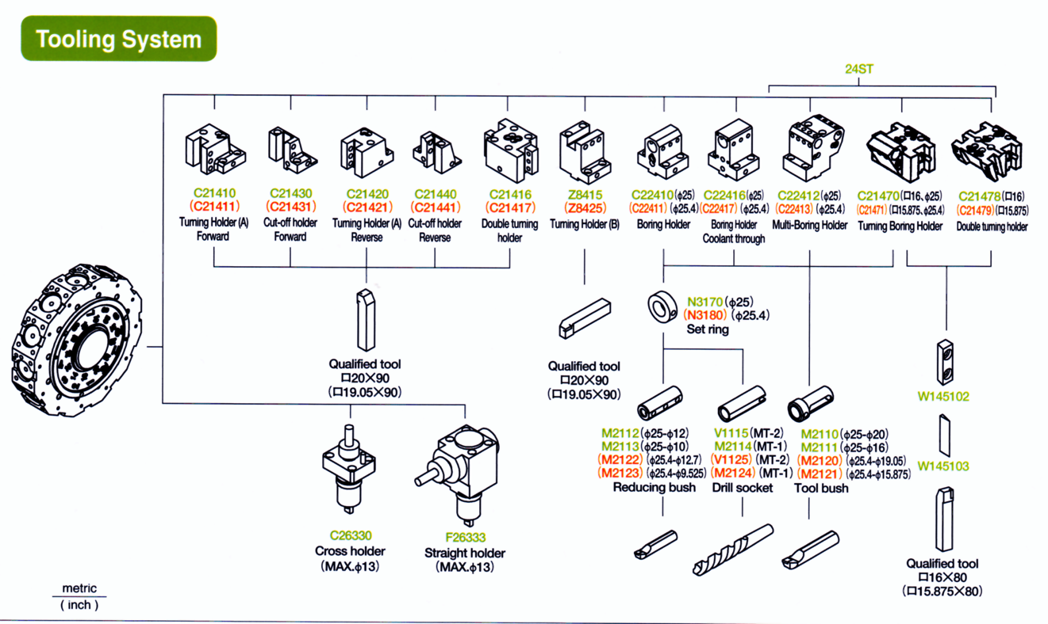
2 Ea. Z8425 3 Ea. M2121
6 Ea. C22411 3 Ea. M2120

OPTIONAL TOOLING

Part No. Description

C21411 Turning Holder A CCW Rotation, 3/4" Shank
C21431AA Cutoff Holder,. CCW Rotation, 3/4" Shank
C21441AA Cutoff Holder, CW Rotation, 3/4" Shank
Z8425 Turning Holder B, 3/4" Shank
C22411 Boring Holder, 1" I.D.
C22413 Double Boring Holder, 1" I.D., 24 Station
C21471 Double Turning Holder., 5/8" Stick, 24 Station
C21479 Double Turning Holder, 5/8" Stick, 24 Station
C22417 Boring Holder Coolant Thru Boring Holder, 1" I.D.

FOR MACHINES WITH MILLING CAPABILITY

C26330 Cross Drill Holder, 6000 RPM, ER20 Collet
C26330C Cross Drill Holder, Internal Coolant, 6000 RPM, ER16A Collet
C26330S Cross Drill Holder, 12000 RPM, 2:1 Ratio, ER20 Collet
C26333 Face Drill Holder, 6000 RPM, ER20 Collet
C26333C Face Drill Holder, Internal Coolant, 6000 RPM, ER20 Collet
C26333S Face Drill Holder, 12000 RPM, 2:1 Ratio, ER20 Collet
C263332U Radial Holder, Dual Output, ER20 Collet, External Coolant, 6000 RPM
UAT0.5-WT100 0-90 Degree Adjustable Holder, ER11 Collet, 6000 RPM
C26440 HT-4 Quick Change Axial Tool Holder
C26440C HT-4 Quick Change Axial Tool Holder - Coolant Thru
C26444 HT-4 Quick Change Radial Tool Holder
C26444C HT-4 Quick Change Radial Tool Holder - Coolant Thru
C26444-2U HT-4 Quick Change Radial - Dual Output Tool Holder
C26801 HT-4 Quick Change Insert ER16
C26802 HT-4 Quick Change Insert ER20
C26803 HT-4 Quick Change Insert ER25
C26448 Radial Disk Hobbing Tool 1/2" Arbo 2000RMP 2:1 Ratio
MA-1.5-2U Axial Dual Output Tool Holder ER16A
MA-1.5-3U Axial Triple Output Tool Holder ER16A
M90-1.5-2 Radial Dual Output Tool Holder ER16A

Standard Configuration:
Controlled Axis
Controlled axes 13 axes
Simultaneously controlled axes Upper 4 axes (L: X, Z, C, Y) + 4 axes (R: X, Z, C, Y)
Simultaneously controlled axes Lower 5 axes (X, Z, C, B, Y)
Input Command
Least input increment X, Z, Y, B: 0.001mm / 0.0001inch (Diameter for X-axis)
C: 0.001deg
Least command increment X: 0.0005mm, Z: 0.001mm, Y: 0.001mm, B: 0.001mm
C: 0.001deg
Max. Programmable dimension +/-999999.999mm, +/-39370.0787inch
+/-999999.999deg
Absolute / Incremental programming X, Z, C, Y, B (B: absolute only) / U, W, H, V
Decimal input
Program code EIA / ISO automatic recognition
Inch/metric conversion G20 / G21
Programmable data input G10
Interpolation
Positioning G00
Liner interpolation G01
Circular interpolation G02 / G03, CW / CCW
Polar coordinate interpolation
Cylindrical interpolation
Feed Function
Cutting feed
feed / minute X: 1 - 4800mm/min , 0.01 - 188inch/min
feed / minute Z: 1 - 4800mm/min , 0.01 - 188inch/min
feed / minute C: 1 - 4800deg/min
feed / minute Y: 1 - 4800mm/min , 0.01 - 188inch/min
feed / minute B: 1 - 4800mm/min , 0.01 - 188inch/min
feed / revolution 0.0001 - 4800.0000mm/rev.
feed / revolution 0.000001 - 50.000000inch/rev.
Dwell G04
Feed per minute / Feed per revolution G98 / G99
Thread cutting G32+F
Thread cutting retract

Feed Function
Continuous threading
Variable lead threading G34
Handle feed Manual pulse generator
0.001 / 0.01 / 0.1mm (per pulse)
Automatic acceleration/deceleration
Liner acceleration/deceleration after cutting feed
Rapid feed override F0 / 25 / 100% (10 - 100% by every 10%)
Cutting feed override 0-150%, (by every 10%)
AI contouring control I G5.1
Programming Function
Part program storage length 1,280m (for 3 turrets total)
Part program editing delete, insert, change
Program number search
Sequence number search
Address search
Number of registered programs 1,000 programs (for 3 turrets total)
Program storage memory Backed up by battery
Simultaneous editing of plural programs * This function is not available during automatic mode
of gantry loader
DNC operation through memory card (Not including memory card)
*One turret is accessible to memory card at the same time
Expanded part program editing
Operation & Display
Operation Panel
Display 10.4" color LCD
Keyboard Flat keyboard
Display function Position, command, offset data, parameter data, etc.
Display language Japanese, English, German, French, Chinese,
Italian,Korean, Spanish, Dutch, Danish, Portuguese, Polish, Hungarian, Swedish, Czech
Manual Data Input (MDI) function (Max. 511 letters)
Optional path name display
Display of run hour and parts count
Clock function

I/O Device
I/O interface RS-232C
Memory card interface
Ethernet (10/100 Base-T)
STM Function
Spindle function (S-function) S-4 digit (direct designation)
Constant surface speed control G96 / G97
Tool function (T-function) T-4 digit (fist 2 digits: tool number / Last 2 digits: Offset number)
Tool Offset
Tool geometry/wear offset first 2 digits: Geometry / Last 2 digits: Wear
Tool nose radius compensation G41 / G42 / G40
Number of tool offset pairs 99 pairs (for each turret)
Direct input of tool offset value measured (Position record switch is an option)
Automatic tool offset
Y-axis offset
Work Coordinate System
Manual reference point return
Auto reference point return G28
2nd reference point return G30
Reference point return check G27
Automatic coordinate system setting
Coordinate system setting G50
Coordinate system shift
Direct input of coordinate system
shift value measured
Work coordinate system setting G52 - G59

Operation Assist Function
Label skip
Single block
Optional stop
Optional block skip
Dry run
Outside/Inside clamp switching for chuck (Switching by NT nurse screen)
Machine lock (Switching by NT nurse screen)
Program check (Switching by NT nurse screen)
Manual absolute (Parameter setting)
Parity check
Control in/out (Comment insert function)
Air cutting mode (Switching by NT nurse screen)
Jump programming (Setting by NT nurse screen)
Program Assist Function
Circular interpolation R programming
Direct drawing dimension (Direct drawing dimension is standard)
or programming chamfering/corner rounding
Canned cycle G90, G92, G94
Multiple repetitive canned cycle G70 - G76
Multiple repetitive canned cycle II
Canned cycle for drilling G80 - G89
Axis re-composition * Used for C-axis control from lower turret
Sub-program
Help function
Balance cut G68, G69
Custom macro
Addition to custom macro common variables #100～#199, #500～#999
FS15 tape format
Luck-bei II (NT Manual Guide i) - including -
1) Turning process cycle making function
2) Milling process cycle making function
3) NC program solid animated cartoon function
4) Display of tool path
5) Fixed program form insert
6) NC program editing function (cut, copy and paste)
7) Tabularized program editing display
8) Program check by each spindle
9) Set up support
etc.
NT nurse 2 - including -
* Japanese, English, German, French, Italian 1) Tool counter
or Spanish is available. 2) Spare tool index
3) Workpiece counter
4) Load monitoring
5) Software work pusher
6) Software cut off detection
7) Software quill pusher
8) Software operation panel
9) Quick offset
10) Transfer cycle
11) Quantitative offset
12) Involute curve machining cycle
13) Drill breakage detection with high accuracy
14) Peck feed drilling
15) Arbitrary axis torque limit function
16) Modal G code initializing function
17) Work coordinate system setting by G-code
18) Bar feeder cycle function
19) Tool setter cycle
20) Idling operation
21) Slope circular interpolation cycle
Mechanical Error Compensation
Backlash compensation
Stored pitch error compensation
Straightness compensation
Machine Assist Function
Built-in PC 64,000 steps
Rigid tap
Spindle synchronization control
Spindle orientation (360 degree by each 0.008 degree)
Automation Assist Function
Skip function G31
NT work navigator Torque type
Z-axis abnormal load monitoring function
Multi step skip
High speed skip
Safety & Maintainability
Emergency stop
Edit key (Setting by NT nurse screen)
Stored stroke limit
Over travel
Self-diagnosis I/O signal diagnose, etc
Alarm history display
Operation history display
Tool post interference check
Servo adjustment screen
Abnormal load detection
Periodic maintenance screen
Maintenance information display
NT operation message display
NT guidance display
Chuck, tailstock barrier or stored stroke check 2, 3 Chuck, tailstock barrier is standard
Auto data back up
Enclosure& Environmental Requirements
Enclosure construction Fully enclosed dust proof
Power supply DC24V +/-10% 4A
Environmental requirements
Temperature 0 - 45 degree C
Temperature Change 0.3 degree C /min
Humidity Less than 75% (No condensation)
Vibration Less than 5m/s (0.5G)
Servo system
Servo motor AC servo motor
Servo unit Transistorized PWM control
Position encoder Absolute position pulse encoder
Relative position encoder for C-axis

Optional Functions
3rd / 4th reference point
Sequence number collation stop
Part program storage length 2,560m
5,120m
10,240m
20,480m
Number of registered programs 2,000 programs
Position encoder 4,000 programs
Directory display of floppy cassette
Direct input of measured offset value B
Direct input of measured offset value B for spindles lathe
Manual handle retrace
Net monitor
* This is the software to monitor machine
through personal computer
(Japanese or English is available)
1) Operation monitor
2) Operation graph
3) Wear offset graph
4) Custom macro
5) Machining program management
6) Mail notice
7) CNC screen display

CNC Control Additional Options
3rd/4th reference position return $650
Sequence number collation stop $300

Methods Machine Tools, Inc. (“Methods”) offers to sell equipment (“Equipment”) and/or services (collectively, “Products”) to the purchaser (“Purchaser”), only on the following terms and conditions. Purchaser’s acceptance of this offer is expressly limited to these terms and conditions, and Methods objects to Purchaser’s inclusion of any different or additional terms or conditions in any written or oral communication. If Methods is deemed to have accepted an offer of Purchaser to purchase Products, then Methods’ acceptance is expressly conditioned on Purchaser’s assent to any different or additional terms or conditions herein. PURCHASER’S PLACEMENT OF ANY ORDER FOR, OR ACCEPTANCE OF, ANY PRODUCTS, WILL CONCLUSIVELY INDICATE ITS AGREEMENT WITH THE FOREGOING.

1. Prices.
Unless otherwise stated in writing, all prices are quoted FOB Methods’ facility. Purchaser will pay all charges and assume all risks of transportation from the FOB point. In the absence of specific written instructions, Methods will route shipments.

All prices may be withdrawn at any time prior to the acceptance of Purchaser’s order by Methods’ home office; and will not be effective for more than thirty (30), days.

Prices do not include any taxes or duties of any kind. If not included in the invoice for Products, such taxes or duties may be invoiced at a later date. Purchaser must show written proof of tax exempt status prior to invoicing. Prices to Canada are quoted at Canadian point of entry.

2. Terms of Payment.
Purchaser’s payments for non-turn-key Products will be ten percent (10%) of the total order amount accompanying the purchase order, with the balance due net thirty (30) days from the date of invoice. Late payments are subject to an interest charge of 1 1/2% per month on the outstanding balance.

Purchaser’s payments for turn-key Products will be (i) fifteen percent (15%) of the total order amount accompanying the purchase order, (ii) sixty-five percent (65%) upon successful run-off and demonstration of Product at Methods, and (iii) twenty percent (20%) net thirty (30) days after installation.

All payment schedules are subject to approval by Method’s credit department, and all amounts are payable in U.S. funds unless otherwise stated in writing. In the event Methods initiates proceedings to collect any amount due from Purchaser, Purchaser will be liable for all collection costs and expenses, including, but not limited to, Methods’ legal fees.

3. Cancellation Charges.
By Purchaser. Purchaser may not and shall not cancel any purchase/sale of the Products, without written consent of Methods. Purchaser may request Methods to cancel a purchase/sale of the Products, and at Method’s sole and exclusive discretion, Methods may agree to a cancellation if the purchase order relates to (i) a standard product (as determined by Methods) and Purchaser pays to Methods an amount equal to fifteen (15%) of the sales/invoice price; or (ii) turn-key Products and Purchaser pays to Methods twenty percent (20%) of the total sales/invoice price and all costs incurred to the date of cancellation, including but not limited to, design, engineering, materials, manufacturing and tooling. Special Products shall not be subject to cancellation under any circumstances. No cancellations shall be allowed after the scheduled shipment date. In the event of any attempted cancellation or refusal to accept Products that are not subject to cancellation, Purchaser shall indemnify Methods for any and all losses sustained by Methods by reason of such attempted cancellation or refusal to accept Products.

By Methods. Methods reserves the right to cancel any purchase/sale and/or decline to complete any sale if in Methods opinion, Purchaser’s creditworthiness is not acceptable (or has become unacceptable) to Methods at any time prior to the shipment of the Product(s) to Purchaser.

4. Delivery .
Methods will not be liable for any unavoidable delays in shipment. Estimated delivery dates in quotations (a) are based on the assumption that drawings, special documentation or special components, if applicable, are received from Purchaser in accordance with the schedule specified by Methods; and (b) are subject to prior sale of the Equipment in question and written confirmation by Methods’ home office. The Products shall be kept at the premises listed on the purchase order, or if none is specified, at the Purchaser’s primary business address and shall not be removed, transferred to a third party, or gifted without Method’s prior written consent.

5. Warranty of Equipment and Limitation of Liability.
Methods warrants only to the original Purchaser, and to the original user, if Purchaser resells Equipment covered hereby but not to any other person or entity, that for a twelve (12) month period from its date of shipment of any Equipment, Methods will repair or replace any Equipment which is defective in material or workmanship, at no cost to Purchaser for any material or parts used. Replacement parts will be warranted for the remainder of the twelve (12) month Equipment warranty, or the manufacturer’s standard written warranty for such parts, whichever is longer. Equipment (i) which has not been installed, maintained and operated under proper conditions by competent, adequately trained personnel, or (ii) which has been subject to abuse, misuse, accident, neglect or unauthorized alteration, repair or installation, is not covered by this warranty. Products provided by any person or entity besides Methods as well as services and normal wear items of Equipment, are not covered by this warranty. Methods will make the final determination, at its reasonable discretion, as to the existence and cause of any alleged defects. Not withstanding the foregoing, Methods does not warranty Used Equipment which is sold as is.

Warranties made by Methods in these Terms and Conditions of Sale are in lieu of all other warranties, oral or written, express or implied, by operation of law or otherwise, and except as explicitly set forth in these Terms and Conditions of Sale, no statement, representation, promise, affirmation of fact or specifications made by Methods or any other person or entity constitutes a warranty. Where performance specifications and/or production estimates are given to Purchaser, whether oral or written, they are estimates only, and are not warranties or guaranties of any type. All warranties of merchantability and fitness for a particular purpose are excluded from this transaction and do not apply to Products.

PURCHASER’S SOLE AND EXCLUSIVE REMEDY AGAINST METHODS FOR ANY BREACH OF WARRANTY OR FOR ANY OTHER CLAIM WITH RESPECT TO PRODUCTS, INCLUDING NEGLIGENCE OR STRICT LIABILITY, WILL BE THE REPLACEMENT OR REPAIR OF THE DEFECTIVE EQUIPMENT. The choice of the particular remedy will be made by Methods at its sole discretion. Methods will perform repairs or replacements only during regular working hours, in accordance with Methods’ normal, non-emergency service practices. Purchaser agrees that it will provide all necessary access and assistance to Methods in effecting the chosen remedy. Purchaser further agrees that there is no other remedy available to it including, but not limited to, damages for lost profits, lost sales, lost production, downtime, overhead, labor, injury or damage to person or property, spoilage or any other incidental or consequential loss.

All Equipment is sold in reliance on Purchaser’s agreement and covenant that it will be operated only when all safety and protective devices are in place, have all been properly maintained, function properly and are being used, regardless of whether such Equipment has been shown to Purchaser (in person or in photographs, films, videos, brochures or otherwise) with safety devices removed to provide better visual presentation. Neither Methods nor the manufacturer of any Equipment warrants compliance with the U.S. Occupational Safety and Health Act, nor does Methods or the manufacturer warrant compliance with Purchaser’s standards, requirements and conditions which may be part of Purchaser’s inquiry or order. Equipment may not comply with local electrical codes, Nema, ANSI or JIC standards; and if such compliance is mandatory, Purchaser is required to so inform Methods in writing when seeking a price quotation.

6. Claims.
All claims by Purchaser against Methods concerning Products must be in writing and received by Methods within the warranty period and within thirty (30) days of the date of Purchaser’s detection of the alleged basis for the claim. Failure to give written notice of any claim within the time period will constitute a waiver by Purchaser of such claim.

7. Confidentiality.
All drawings, designs, specifications, manuals and programs furnished to Purchaser by Methods shall remain the confidential and proprietary property of Methods. All such information, except as may be found in the public domain, shall be held in strict confidence by Purchaser and shall not be disclosed by Purchaser to any third parties. Copyright in all materials made available by Methods shall remain Methods at all times.

8. Indemnification.
If Equipment is sold hereunder, Purchaser assumes all risk, insurable interest and liability for physical loss, damage or injury to persons or property of Purchaser or others, arising out of the use or possession of Equipment prior to title passing and thereafter. Purchaser agrees to indemnify and hold Methods harmless from any and all claims or liabilities asserted against Methods in connection with the use or possession of Equipment.

In the event that any party to this agreement initiates legal proceedings regarding any controversy or claim arising out of or relating to this agreement, or breach thereof, the prevailing party in said proceedings shall be entitled to the recovery of all costs and expenses, including, without limitation, attorney’s fees and experts’ fees.

9. Safety Precautions.
Purchaser shall require all employees to use all safety devices, guards, and proper safe operation procedures set forth in manuals and instructions furnished by Methods. Purchaser shall not remove or modify any such device, guard or sign. It is the Purchaser’s responsibility to provide all the means that may be necessary to effectively protect all employees from serious bodily injury which otherwise may result from the method of particular use, operation or set-up or service of the Products. If Purchaser fails to comply with the provisions of this paragraph or any applicable standards or regulations, Purchaser shall indemnify Methods and the Methods selling companies from and against all claims, losses or damages arising therefrom.

10. Title.
Title to Equipment will remain in Methods until full payment has been received. In the event of a default, Methods will have the right to repossess said Equipment, and whatever money has been paid on account will be deemed to be reasonable rental for the use thereof, to the date of such repossession. Methods will also have the right to hold Purchaser liable for a sum equivalent to the unpaid balance of the purchase price together with all expenses and damages that Methods may sustain. Purchaser will receive credit, however, for the net sum realized on the sale, if any, of Equipment after deduction of all associated costs and expenses. Alternatively, at the election of Methods, Methods may pass title to Equipment to Purchaser, in which event Methods need not repossess such Equipment, but may recover from Purchaser the unpaid balance.

11. Electrical Regulations.
Due to differing requirements of city, county, state, and federal electrical regulations and codes pertaining to industrial equipment and its installation, Methods Machine Tools, Inc. and the machine tool manufacturer are unable to certify compliance to the regulations in effect at the location of equipment installation. Should testing, inspection or modifications to the quoted product be required to achieve compliance, it is the responsibility of the purchaser.

12. Export Control.
The Products (and all information, technology, hardware, firmware and/or software contained therein) are sold for use and consumption within the United States only and Purchaser shall not export the same. Purchaser acknowledges that in the event the Purchaser were to export the Products, any subsequent export, transfer, resale or other disposition of the Products from the United States must be made in accordance with applicable law. Diversion contrary to US law is strictly prohibited. In furtherance hereof, in the event any such export, Purchaser shall (a) comply with all applicable export/export control laws, rules and regulations of the United States and any other foreign countries, governments, agencies or authorities (collectively, the “laws”), and (b) not export or reexport the Products in violation of any such Laws, or without all necessary authorizations/licenses. Purchaser agrees that the export of the Products may require export control licenses or approvals from the U.S. government or foreign governments/governmental agencies or authorities.

In cases where licenses or approvals are required, Methods has not authorized such export(s) and as such, Purchaser shall be solely responsible for obtaining such required licenses or approvals from the appropriate governmental agencies or authorities. Purchaser shall indemnify, defend and hold harmless Methods from and against any and all losses, damages, cost and expenses (including reasonable attorney’s fees) sustained or incurred by Methods by reason of failure of Purchaser to comply with any such laws. Purchaser shall bear all expenses relating to obtaining any necessary licenses and/or exemptions required under the Laws with respect to any export of the Products from the United Sates.

Notwithstanding the above, neither the Products nor the underlying information, technology, hardware, firmware or software, may be exported or re-exported to (a) Cuba, Iran, Sudan, Syria, or any other country subject to U.S. trade sanctions applicable to the Products, (b) individuals or entities controlled by such countries, or to nationals or residents of such countries other than nationals who are lawfully admitted permanent residents of countries not subject to such sanctions; or (c) to any named party or individual on the U.S. Department of Treasury, Office of Foreign Assets Control (OFAC), Specially Designated Nationals List or on the U.S. Department of Commerce, Bureau of Export Administration Denied Persons List or Entity List, or to any other party or individual subject to other government lists applicable to the Products (or any other similar lists that may be promulgated or maintained by the United States government from time to time hereafter)

Upon request by Methods, Purchaser shall provide Methods with all customer information and documentary and other assistance required to maintain strict compliance with the Laws. Purchaser shall take all actions as may be necessary to assure that no customer contravenes any Laws or the provisions of any such approvals/licenses or exemptions. Methods shall be relieved of all obligations to provide any Products, spare parts or technical data to Purchaser (or its customer(s)) if Purchaser (or such customer) violates any Laws, or if any approvals/licenses are suspended or revoked.

13. Interpretation.
These Terms and Conditions of Sale -- together with the consistent terms covering the identity of Products, quantities, prices, delivery instructions and other items specifically agreed to in writing by Methods -- constitute the entire contract of sale and purchase of the Products, and are binding on Methods’ and Purchaser’s successors and assigns. Purchaser, if it resells Equipment, will obtain the consent of the user(s) to be bound hereby and if Purchaser fails to do so, it will indemnify Methods against any loss arising therefrom. No modification of this contract will be binding upon Methods unless in writing and signed by an authorized officer of Methods, nor will any modification be effected by Methods’ acknowledgment or acceptance of any documents of Purchaser containing terms different from those set forth in this document. Any provision set forth in any of Purchaser’s documents which are inconsistent with the terms and conditions hereof is not binding on Methods and is not applicable to the Products. Any reference by Methods to Purchaser’s oral or written communications will not constitute an assent by Methods to any inconsistent term of condition in such communications.

Neither party will be liable to the other for delays or failures in performance, including late delivery and nondelivery, arising from strikes, fire, war, accident, explosion, acts of God, unavoidable production delays of the manufacturer(s) of Equipment, delays in subcontractors’ deliveries, or any other cause beyond its reasonable control; provided, however, that no such cause will excuse Purchaser’s obligation to timely pay all sums of money due hereunder, with respect to which time is of the essence.

The interpretation, validity and performance of the contract between Methods and Purchaser is governed by the laws of Massachusetts, without regard to its conflict of laws doctrine. All disputes relating hereto or arising herefrom will be resolved solely through arbitration before three arbitrators pursuant to the then current rules for commercial arbitration of the American Arbitration Association, with all hearings to be held in Boston, Massachusetts; provided, however, that either party may seek preliminary injunctive relief in court proceedings prior to the resolution of such arbitration.

